Princess Sumaya University for Technology

King Abdullah II Faculty of Engineering

Computer Engineering Department

|  |  |
| --- | --- |
| **Embedded Systems.**  **Project Documentation**  **Rubik’s Cube Solver** | |
| *Authors:* |  | |  |  |
| |  |  |  |  | | --- | --- | --- | --- | | Ibrahim Joudeh | 20200254 | NIS Eng. | Ibr20200254@std.psut.edu.jo | | Taiseer Shenar | 20200908 | NIS Eng. | Tai20200908@std.psut.edu.jo | | Ahmad Issa | 20210166 | Computer Eng. | Ahm20210166@std.psut.edu.jo | |  | |  |  |

***Abstract***

Table of Contents

Introduction 3

Theoretical & Background 3

Designs 3-4

Results 5

Problems 5

Conclusions 5

**Introduction**

Our project is a Rubik’s cube solver, the project is made out of six stepper motors and their drivers to control the ability to move each face of the cube.

We used a cube solving application that scans the cube using a camera to generate the solution, store it in a text file and then send it serially to the pic to control the movement of the motors and solve the cube.

**Theoretical & Background**

We have 12 possible rotations for our cube, each face have 2 rotations, clockwise and counterclockwise.

The rotations are represented in these commands: ***R(right),L(left),U(up),D(down),F(front) and B(back).*** These are the clockwise rotations. Moreover the counterclockwise rotations are represented the same way but with prime. For example R’ commands the right motor to move counterclockwise.

For scanning the cube we used two application. The first application is Iriun, we downloaded it on both the PC and our mobile. This application makes the mobile act like a Webcam to scan the cube. The next application we used was Cube Explorer, you capture each face then the application gives you a series of letters that represent each rotation.

After generating, the commands are sent serially to the pic 16F877A using YP-01 (USP to TTL) to make the stepper motors move and solve the cube.

**Design**

The first step in the design process was to make the schematical prototype of the project on (softwarename) showing all components that we used in the project, the connections between each component and their ports. After completing the schematic we used it to help us complete our connections on the breadboard.

Moreover, we’ve set the currents for each driver using the formula given in the datasheet for each driver. We used three A4988 and DRV8825, then we connected the six stepper motors with their driver, the drivers controls the gear teeth in the stepper motor then turn the gears once (1.8 degrees).we used 50 step signals to rotate the motor rotor 90 degrees.

We wrote a python code to open a text file and divide its contents. If the chunk contains a prime the letter it will be sent as a lowercase letter through serial communication (COM13) which will move the stepper motor 90 degree counterclockwise. Else it will be sent as is (uppercase) which will move the stepper motor 90 degree clockwise.

These commands are sent from an application called Cube Explorer, which gives you the solution of the cube after scanning it with our phone using (Iriun) to make the phone act like a Webcam.

We started the hardware work by cutting the base using laser cutting CNC. Then we used the 3D printer to print six pieces that will lock the cube in place.

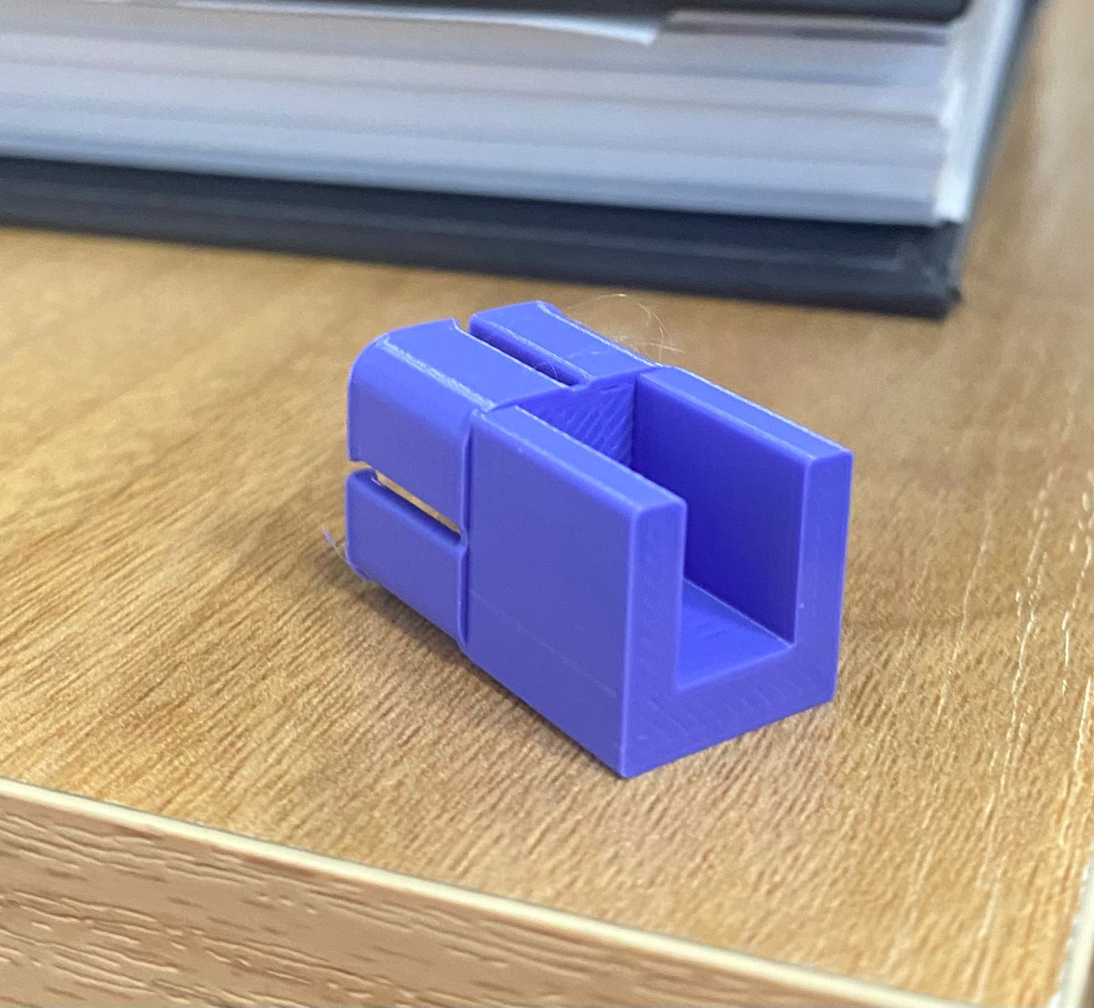

In addition we used a 12V voltage source.

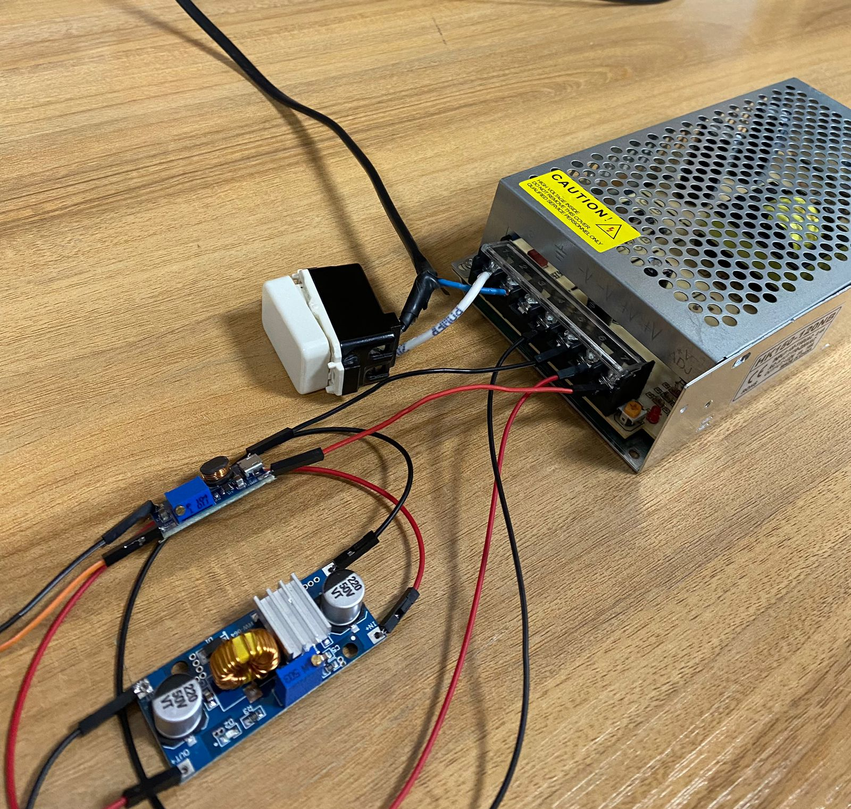

**Results**

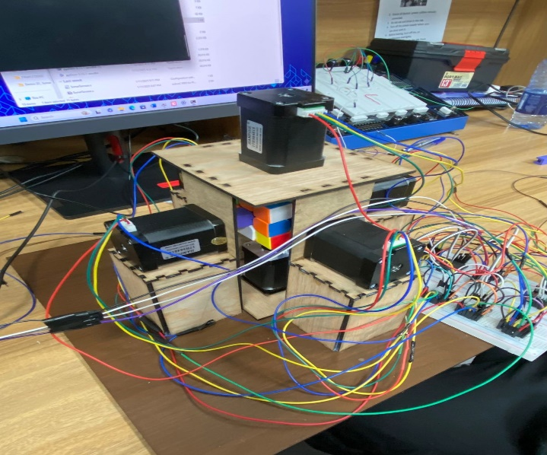

Our result was more than satisfying. The project was able to solve the Rubik’s in manageable time (30 sec on average)

**Problems**

The first problem we faced was setting the currents on the drivers, after we’ve done that we were looking for the DRV8825 only 3 were available in Jordan, instead we used A4988, which burnt twice with us.

Lastly the Rubik’s was unstable due to the movement of the bottom motor, thus we locked the motor with screws to stabilize it.

We faced many problems from code errors to mechanical to electric errors but in the end our hard work payed of and we solved every problem.

**Conclusion**

To conclude, our project is a Rubik’s cube solver that solves the cube with the help of six stepper motors and their drivers.